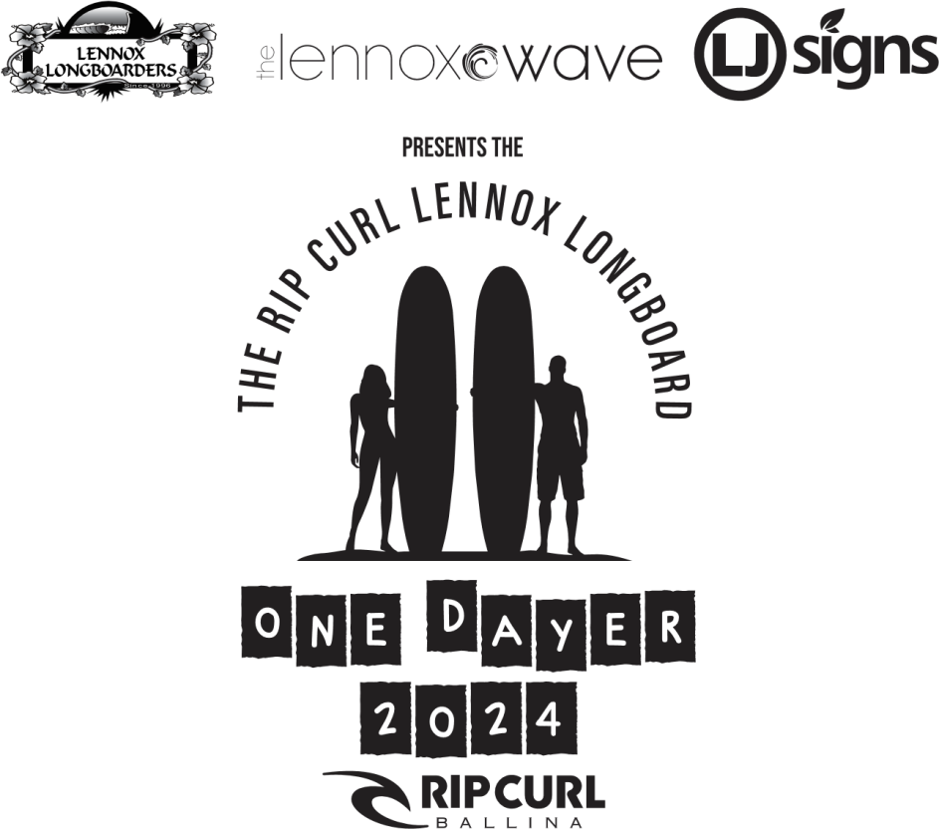
The RIPCURL Lennox Longboard “One Dayer” 2024 Saturday March 23
DIVISIONS
Open 9ft - 18 spots Over 40's - 12 spots
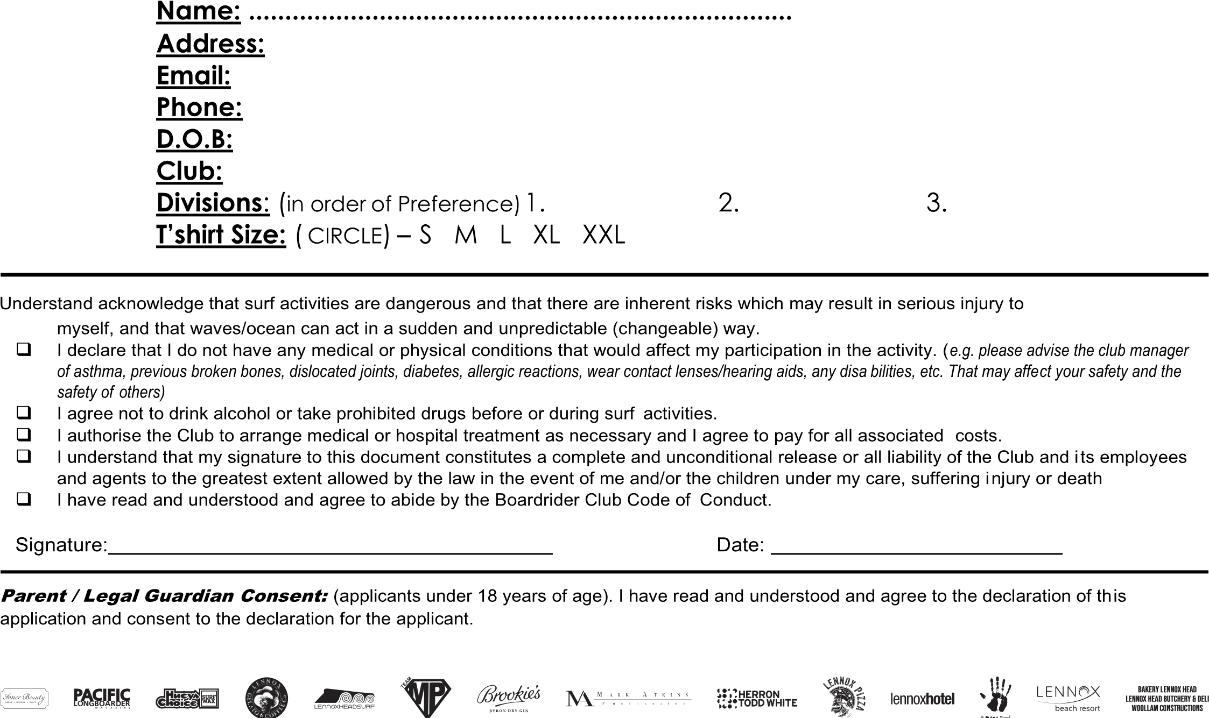
Over 60's - 18 spots Ladies Open - 12 spots Ladies over 40s - 12 spots
ALL DIVISIONS 9ft MINIMUM Age as of the 22nd March Multiple entries accepted
ENTRY FEE: $60.00 (per division) & MUST ACCOMPANY ENTRY with proof of payment. Entries close: Friday March 15th 2023
ELECTRONIC ENTRY/PAYMENT: Account Name – Lennox Longboarders Club, BSB-722744, Account No-100015922
ENTRY FORMS/ENQUIRIES to: George Leslie @ Comp Email – siaosi45@islandstyle.net.au or 0414935951
Competition draw will be placed on the Club Websitewww.lennoxlongboarders.org 5 days prior
POSTAL ENTRIES: Lennox Longboarders Club . C/- PO Box 408, Lennox Head NSW 2478 Cheque to: Lennox Longboarders Inc

